Field no. G. Only in case of no loans given to Associate/group companies Please insert “0” in Secured and unsecured loans, associate details may be inserted Insert N.A./Not Applicable in loan details Click on add button (Refer below mentioned screenshot)

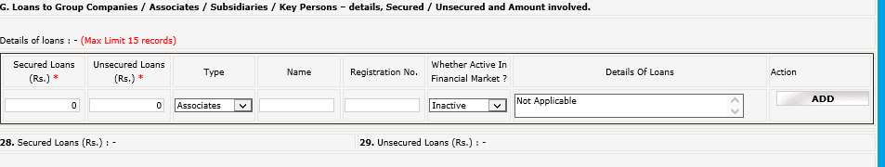

After adding the detail, it will appear as per below screenshot :

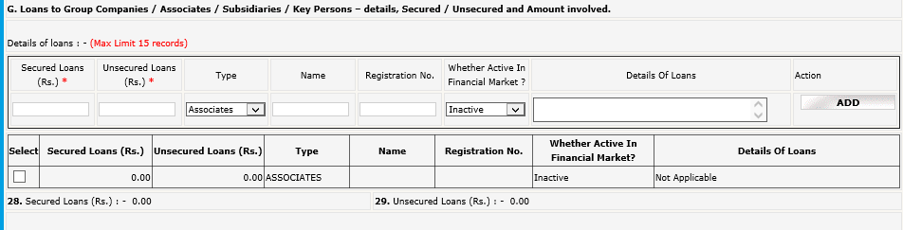

Kindly note that in case of Loans given, it is mandatory to fill all the details of loan given in the above-mentioned table.

Field no. F: “Insurance Details : “
Click Add button after entering data
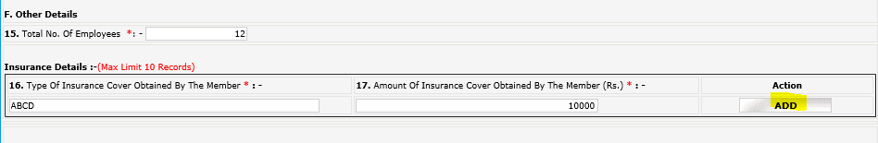
The records inserted will be reflected as below after clicking ADD button:

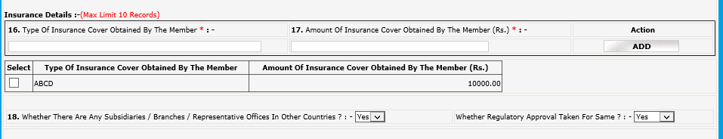

Field no. 20: Brokerage Income: - Consider Gross brokerage revenue from broking operations across all exchanges.

Field no. 22: Total debit balance of all Clients: - Consider total debit balance of all clients across all segments and exchanges as on September 30, 2023 .

Field no. 23: Total Available Collaterals from All Debit Balance Clients: - Consider total available collaterals (Free & un-encumbered) from debit balance clients (as considered for the above point) as on September 30, 2023 . POA stocks to be excluded

Field no. 24: Total Amount of Delayed Payment Charges Collected from The Clients: - Consider Total Amount of late/delayed payment charges levied on clients during the Year ended September 30, 2023 (across all exchanges)

Field no. 30: Subpoint “Number of Instances *: “ = Number of instances of Fraud
Field no. 31: Subpoint “No. of SEBI inspections *: “ = Number of inspections by SEBI
Field no. 32: Action by Police/Foreign Regulator
Field no. 35: Number of instances of Disciplinary Action against Key Person

Field no. L: The entities wherein PAN is not applicable shall be termed as “PANNOTAPPL”. However, it is mandatory for the member to specify reasons in case of non-applicability of PAN in the column “Reasons for PAN not applicable”.

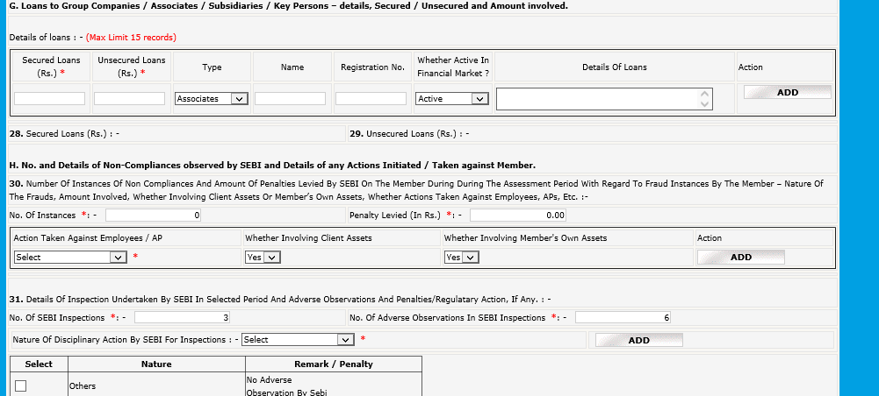
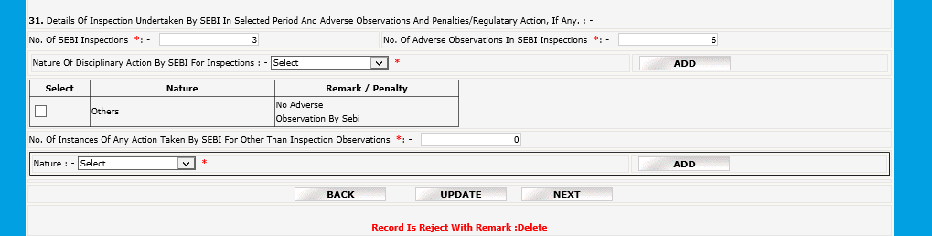
In case of 0 instances, insert 0 in no. of instances/No. of SEBI inspection, press tab, tab…, finally update/save the data
(Note:- Action is just option display, will not be added as part of data, in case of 0 instance)

