User manual for Quarterly Compliance Certificate Through BEFS
- Member enters into the BEFS (System) by entering Login details.
- To login to BEFS system
- Go to URL: http://befs.bseindia.com/

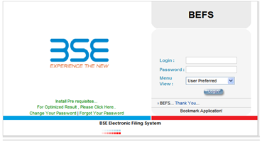
Screen number 1
LOGIN CAN BE DONE BY USING APPROPRIATE CREDENTIALS
- USERNAME
- PASSWORD
Menu
Execution of order-> Quarterly Compliance Certificate

From Menu shown at Left side of the screen

- Select Execution of Order
- Select Quartely Compliance Certificate

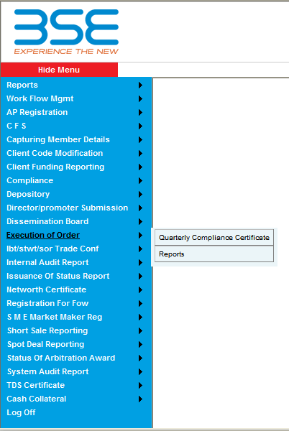
Screen Number 1.1
- On selecting Quartely Compliance Certificate, Following screen appears as shown below
- Select the Financial Year and Quarter(Jan-Mar/Apr-Jun/July-Sep/Oct-Dec)
- Chose the Complied column as ‘YES’ or ‘NO’
- If selected as ‘NO’ the user is required to enter his/her Remarks for non compliance.
- Check on the Undertaking Check box.
- Click on SAVE.
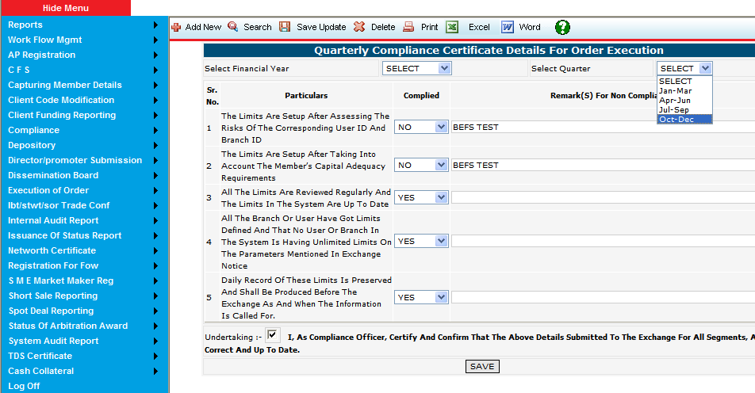Screen Number 1.2
- On Entering the above details, Click on save for which a notification is prompted by the application as shown below
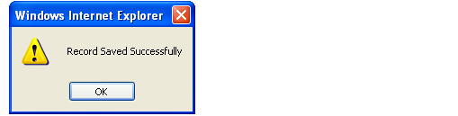
Screen Number 1.3
- Also a notification is prompted as “Email Sent Successfully”.
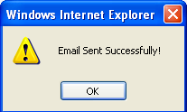
Screen Number 1.4
- The Above Saved data can be searched by clicking on ‘search’ button located on top of the screen(Screen number 1.2)
- Select the quarter.
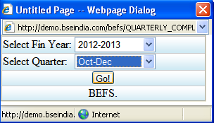
Screen Number 1.5
- Click on ‘GO’ following screen appears as shown below
- The saved entry can be viewed and can be updated By editing the Complied and Remarks(s) section.
- Select Quarter is a Read-only Field and cannot be edited.
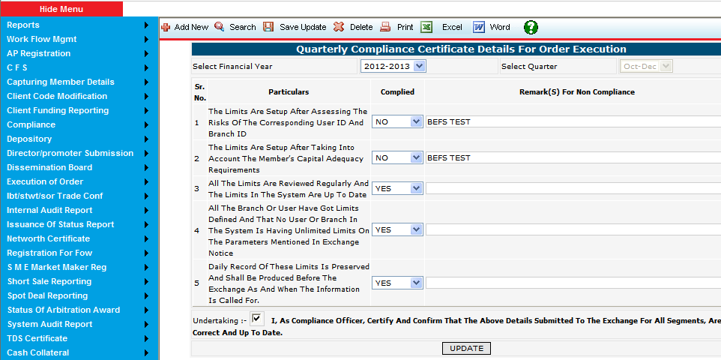 Screen Number 1.6
- Click on Update option
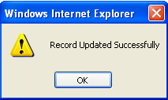
Screen Number 1.7
- Go back to Search option(Screen number 1.5) and view the updated Data as explained above
- Click on ‘Add New’ to add new entries as explained in Screen number 1.2 for the next period.
Menu
Execution of order->Reports
- On clicking upon Reports, Following screen appears
- It is mandatory to chose Quarter in order to view the report
- From Clg, To Clg is Auto populated,(The logged in member’s Id will be displayed)

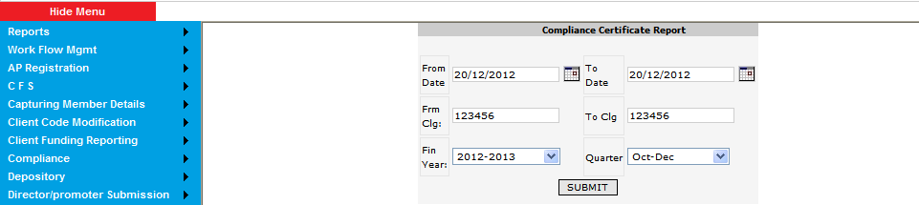Screen number 2
- Click on Submit, Following screen appears as shown below
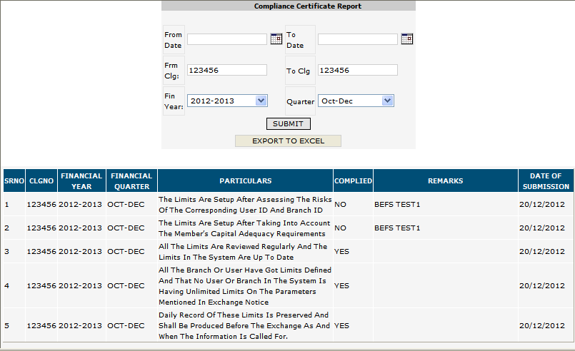 Screen number 2.1
- Also a provision to view the report in excel format is facilitated By clicking on ‘Export to Excel’
Note: The above Remarks section are the updated entries as mentioned in screen number 1.6

