

2020



BSE Limited
User Manual for submission of Cyber Security & Cyber Resilience Audit Report

- Member will login to BEFS with user credentials. System will block login ID if user enters wrong password three times.
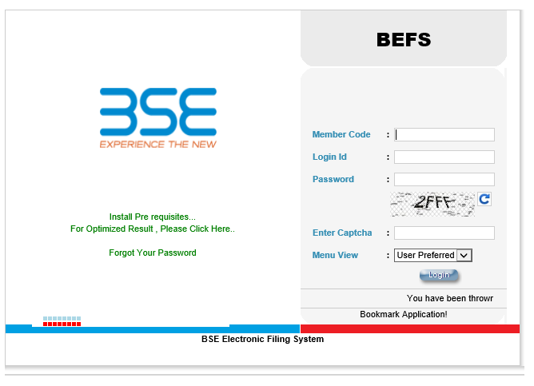

- After successful login, system will open home page and menu is available on the left hand side. Cyber Security & Cyber Resilience Audit > Cyber Security & Cyber Resilience Audit Submission Form

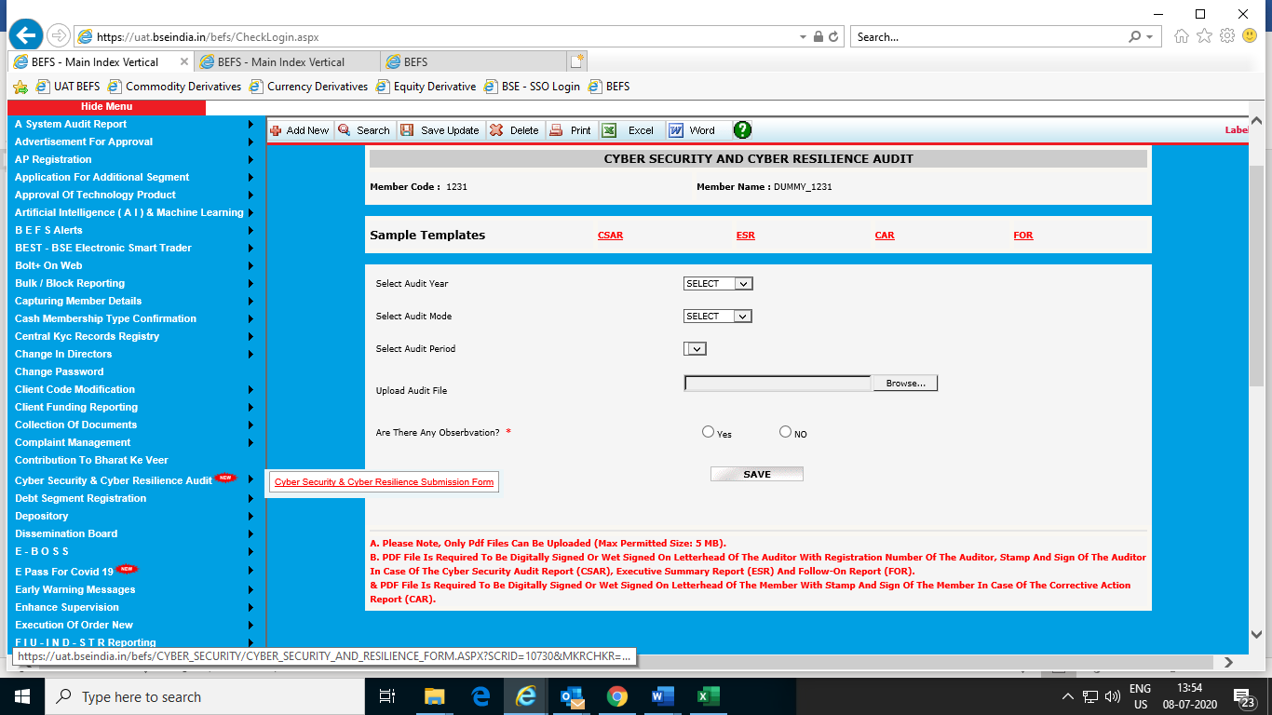

- Select the “Audit Year” from the drop-down list and then select “Yearly” or “Half Yearly” under “Audit Mode” and then select “Audit Period” whichever is applicable.

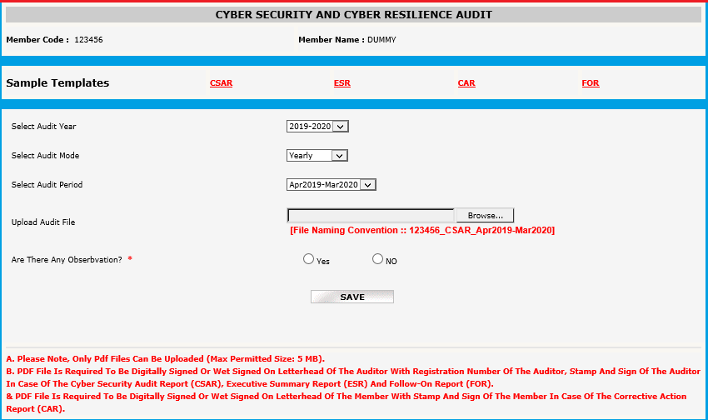

- To submit the Cyber Security & Cyber Resilience Audit Report (CSAR), download the template from the “CSAR” link given on top of the page.

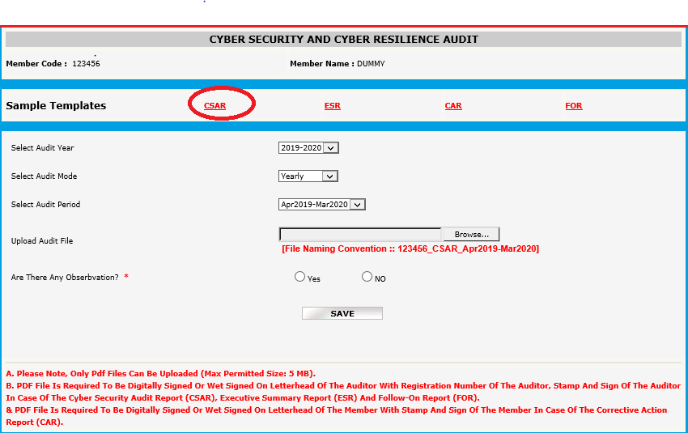

- Once the CSAR is filled and signed, stamped by the Auditor, browse to submit the Cyber Security & Cyber Resilience Audit Report (CSAR) in PDF format. The question “Are there any Observation?” is displayed. Select “Yes” or “No” for the question.
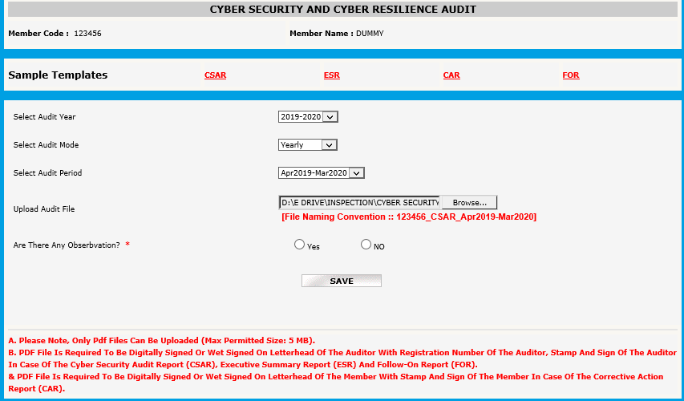

- If any observation is identified as Non-compliance/work in progress/observations or suggestions, then select “Yes” for the question “Are there any Observation?”. Then a text message is displayed “Kindly upload the Executive Summary Report”. Click on “OK” to proceed.
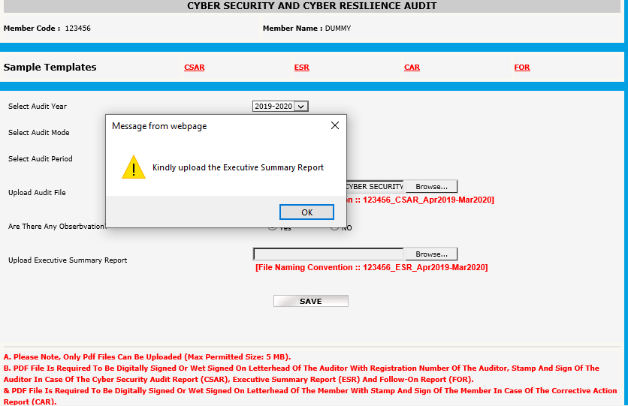

- To submit the Executive Summary Report (ESR), download the template from the “ESR” link given on top of the page. Kindly note that it is mandatory to submit the Executive Summary Report even if there are no observations in the Cyber Security & Cyber Resilience Audit Report (CSAR).
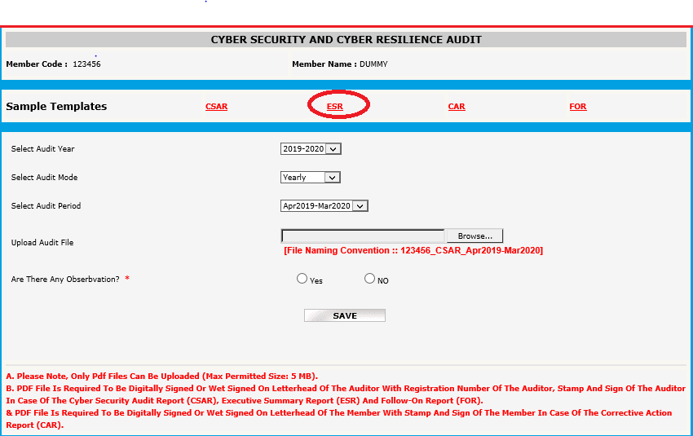

- Once the ESR is filled and signed, stamped by the Auditor, browse to submit the Executive Summary Report (ESR) in PDF format and click on “Save”.

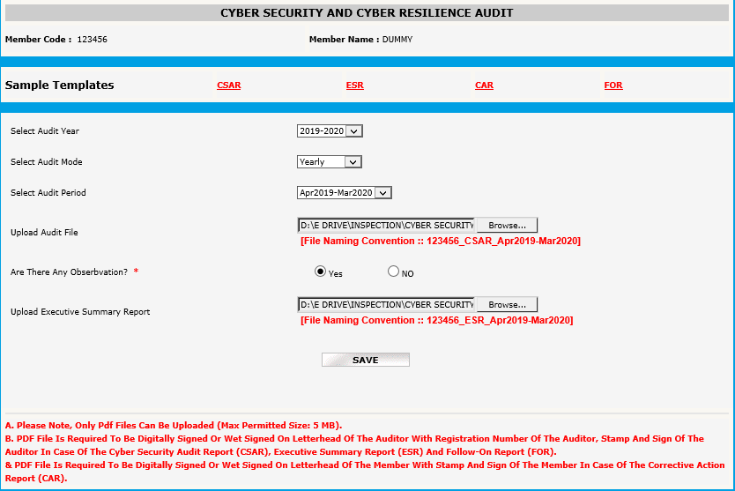

- The following text message will be displayed once data is successfully saved for Cyber Security & Cyber Resilience Audit Report (CSAR) and Executive Summary Report (ESR).

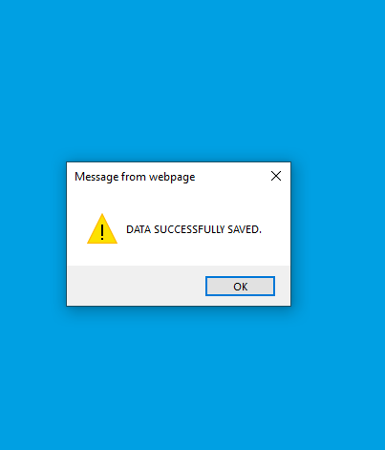

- Then “Update” and “Submit” options will be displayed at the end of the page.

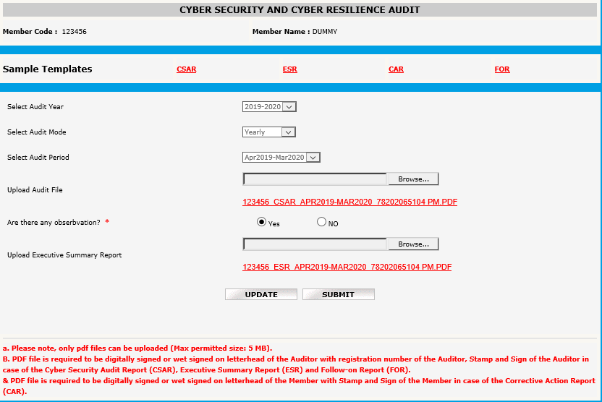

- Click on “Update” and the following text message will be displayed.

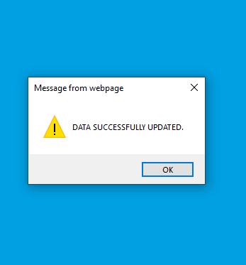

- Now click on “Submit” to finally submit the Cyber Security & Cyber Resilience Audit Report (CSAR) and Executive Summary Report (ESR). The following text message will be displayed, and email will be received by the member as an acknowledgement for successful submission of Cyber Security & Cyber Resilience Audit Report (CSAR) and Executive Summary Report (ESR).

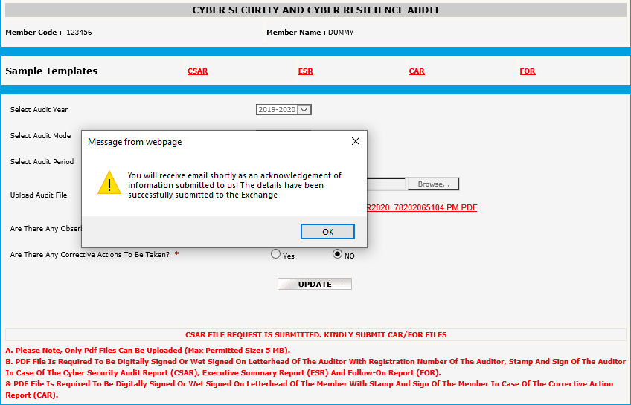

- In case there are any corrective actions advised by the Auditor, then select “Yes” for the question “Are there any Corrective Actions to be Taken?” or else select “No” for the question “Are there any Corrective Actions to be Taken?” and then click on “Update” to proceed directly to point no. 20 of this document.

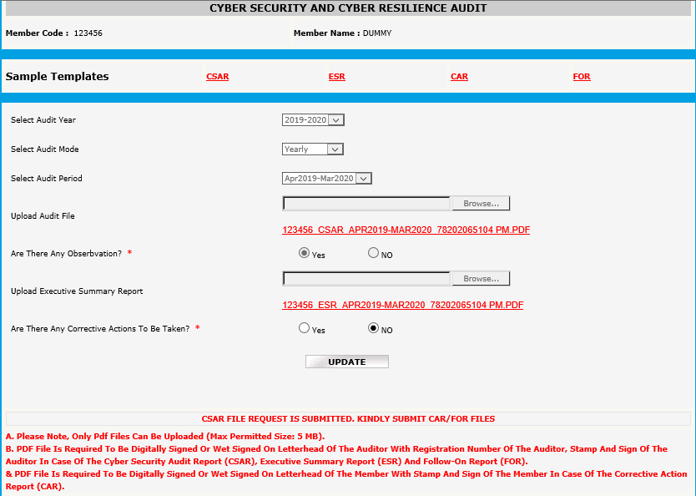

- In case there are any corrective actions advised by the Auditor, then the Member is required to submit the ‘CORRECTIVE ACTION REPORT (CAR)’. After the Cyber Security & Cyber Resilience Audit Report & Executive Summary Report (ESR) is uploaded, the member can upload the Corrective Action Report (if applicable). Once “Yes” is selected as per point no. 13 above, the option to browse the Corrective Action Report will be displayed.

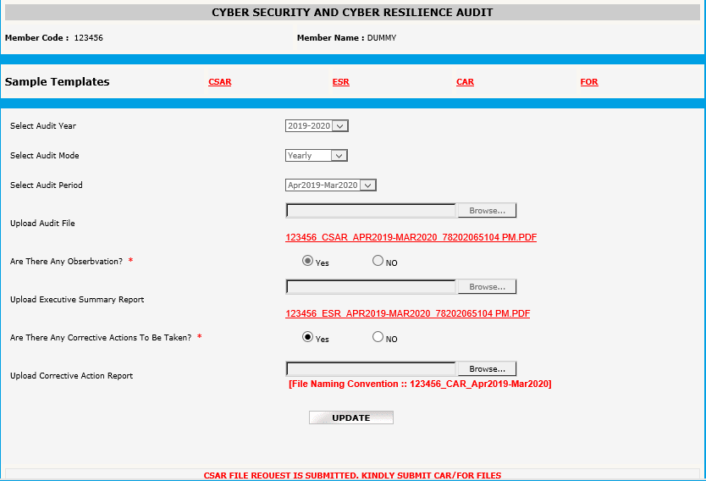

- To submit the Corrective Action Report (CAR), download the template from the “CAR” link given on top of the page. Once the CAR is filled and signed, stamped by the Member, browse to submit the Corrective Action Report (CAR) and click on “Update”.

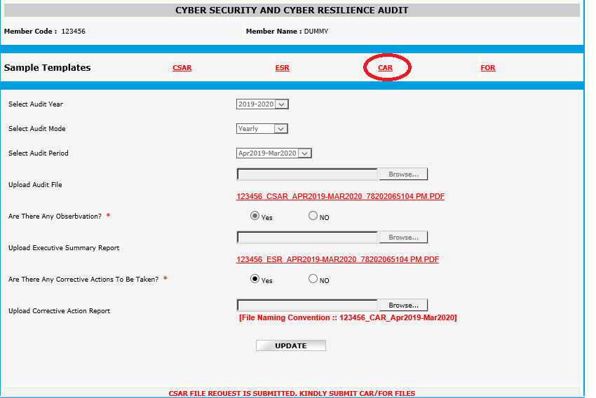

- Upon clicking on “Update”, the following text message will be displayed.

- Then “Update” and “Submit” options will be displayed at the end of the page.

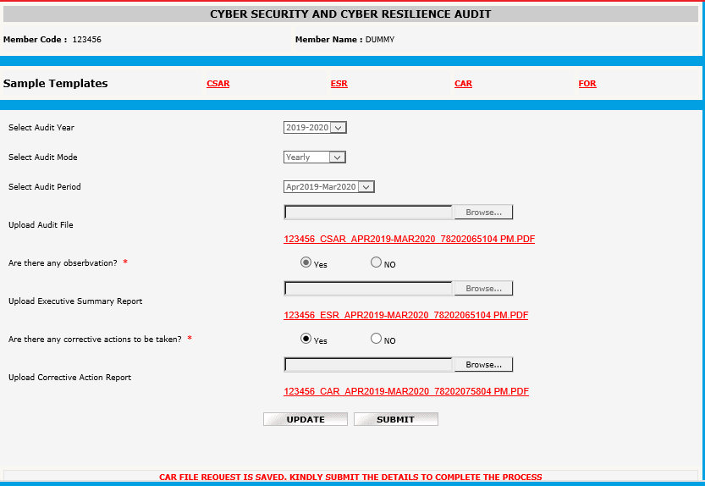

- Click on “Update” and the following text message will be displayed.

- Now Click on “Submit” to finally submit the Corrective Action Report (CAR). The following text message will be displayed, and email will be received by the member as an acknowledgement for successful submission of Corrective Action Report (CAR).

- If Follow on Report is applicable to Member, then select “Yes” for the question “Is Follow On Report to be submitted?” or else select “No” and then click on “Update” and “Submit” to complete the submission process to the Exchange.

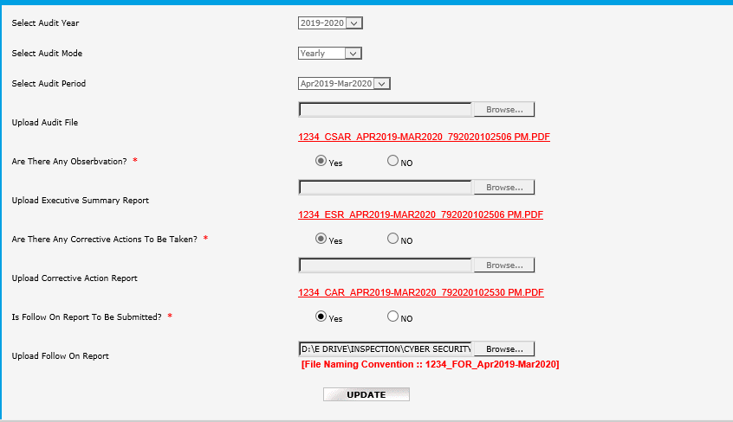

- To submit the Follow on Report (FOR), download the template from the “FOR” link given on top of the page. Once the FOR is filled and signed, stamped by the Auditor, browse to submit the Follow on Report (FOR) and click on “Update”.

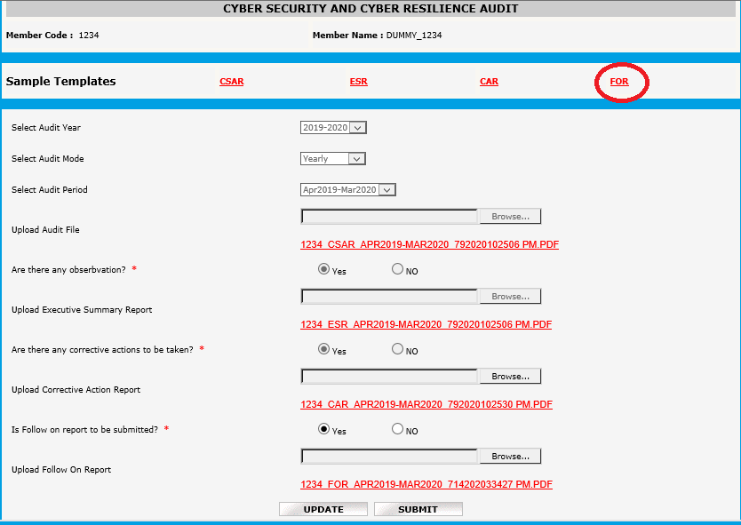

- Upon clicking on “Update”, the following text message will be displayed.

- Now Click on “Submit” to finally submit the Follow on Report (FOR). The following text message will be displayed.

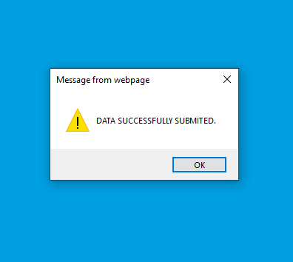

- Then the following text message will be displayed, and an email will be received by the member as an acknowledgement for successful submission of Follow on Report (FOR).
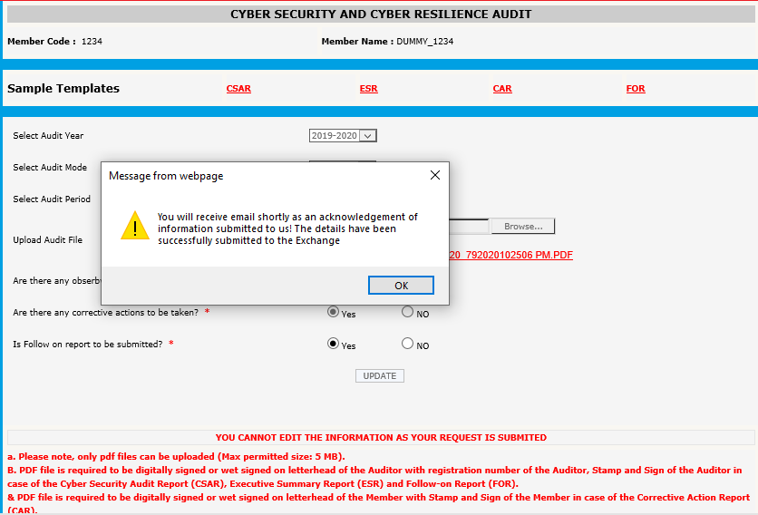

NOTE: After clicking on “Submit”, no further changes or modifications are allowed in the uploaded audit reports.

- To search for the submission of any reports, click on “Search” option on the top of the page and enter the requisite details and click on “GO” to see the previous submissions.

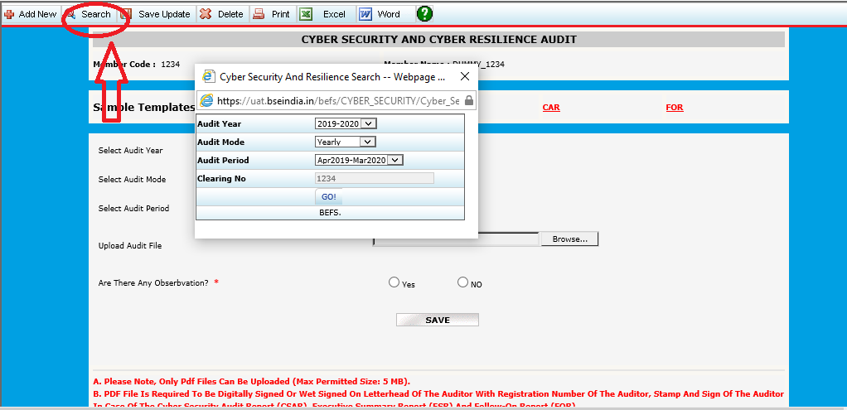

*****END OF DOCUMENT*****

