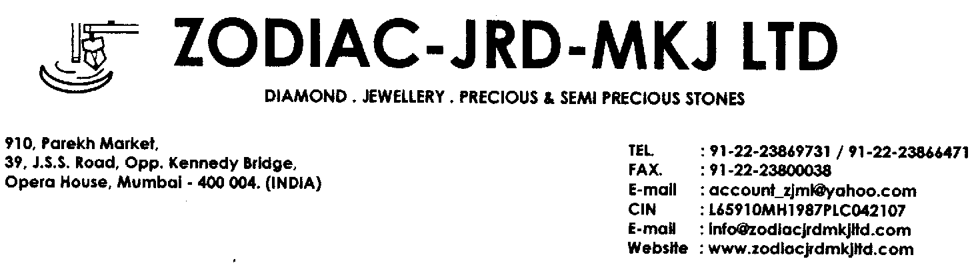

Date : May 6, 2020

To,

Shubham Daliya

On-line Surveillance

BSE Limited

Phiroze Jeejeebhoy Towers

Dalal Street

Mumbai 400001

.

**Sub: Clarification on Price Movement**

With reference to the email dated May 6, 2020, Ref. No.: L/SURV/ONL/PV/**NK**/**2020-2021**/**387**, with regard to significant movement in the price of our securities, for which exchange has asked for clarification.

We wish to inform you that we have no information or any impending information which in our opinion may have a bearing on the price /volume behavior in the scrip further we would also like to mention that we have complied with Regulation 30 of the Securities and Exchange Board of India (Listing Obligations and Disclosure Requirements) Regulations, 2015, as required to intimate to the Exchange all the events, information etc that have a bearing on the operation/performance of the company which Include all price sensitive information, etc.

Please note the above information for your records.

Thanking you.

Yours faithfully,

**FOR ZODIAC-JRD-MKJ LIMITED.,**

**Sd/-**

**Jayesh Jhaveri**

**Managing Director**